
FRTB DEFAULT RISK CHARGE · THE 8% (COOKE) FACTOR
Risk Weight or Loss Rate?
The 8% That Stands Between You and a
12.5x Capital Error

Why securitisation DRC needs the Cooke factor — and non-securitisation does not
Prepared by · Market Risk — FRTB Programme
Methodology & Impact Note
Worked from · reference portfolio · drc_securitisation

Contents
1. Executive Summary — the 12.5x trap
2. Two meanings of 'risk weight'
3. Non-securitisation — the risk weight is a loss rate
4. Securitisation — the risk weight is an RWA weight
5. The 8% bridge and the 1250% ceiling
6. The 12.5x error, worked from trading book
7. The '100%' trap — one number, two scales
8. Why it matters & how the engine gets it right
Appendix A — Capital reconciliation (four positions)
References

1. Executive Summary — the 12.5x trap
In the FRTB Default Risk Charge the word risk weight carries two completely different meanings, and confusing them is the single most expensive arithmetic mistake in the whole calculation. For a non-securitisation, the risk weight is a loss rate — it already is the capital, expressed as a fraction of the exposure, and you apply it directly. For a securitisation, the risk weight is a banking-book RWA risk weight — it is 12.5 times the capital, and you must multiply it by the 8% Cooke factor to turn it back into a capital number.
The two regimes even have different ceilings, and the ceilings give the game away: non-securitisation risk weights top out at 100% (a total loss), while securitisation risk weights run all the way to 1250%. The ratio 1250% / 100% is exactly 12.5 = 1 / 8% — the Cooke ratio. A securitisation weight of 1250% is not '12.5x a loss'; it is the deduction-equivalent risk weight, because 1250% x 8% = 100%.
THE HEADLINE NUMBER Omit the 8% factor on the securitisation book and securitisation DRC leaps from $27.4m to $342.4m — a default-risk charge larger than the entire securitisation portfolio's market value (~$341m). Capital cannot exceed the assets it is held against; a result that does is the unmistakable fingerprint of a forgotten 8%. The error is always the same size: exactly 12.5x, on every position, whatever its risk weight.
This note explains, with the actual portfolio figures, why the two regimes differ, what 100% and 1250% each really mean, and why the 8% is not an optional 'simplification' but the exact inverse of how a securitisation risk weight is defined.
Regime | What the 'risk weight' is | Ceiling | Capital formula | 8% applied?
Non-securitisation (MAR22.24) | A loss rate (capital already) | 100% | RW x net JTD | No
Securitisation (MAR22.34 / CRE40-44) | A banking-book RWA weight | 1250% | RW x 8% x net JTD | Yes
Exhibit 1. The whole note in one row each. Same word — 'risk weight' — on two different scales; the 8% is what bridges them.
2. Two meanings of 'risk weight'
A 'risk weight' in Basel can live on either of two scales, and DRC uses both — one for each branch:
- The capital scale (loss-rate scale). The number is already the capital, as a fraction of the exposure. 100% means 'hold capital equal to the whole exposure' — a total loss. Non-securitisation DRC lives here.
- The RWA scale. The number is a risk weight applied to an exposure to produce risk-weighted assets; capital is then 8% of that RWA. On this scale 100% means 'hold 8% of the exposure' — a normal corporate weight — and you need 1250% to reach a full deduction. Securitisation DRC lives here, because it imports the banking-book securitisation risk weights.
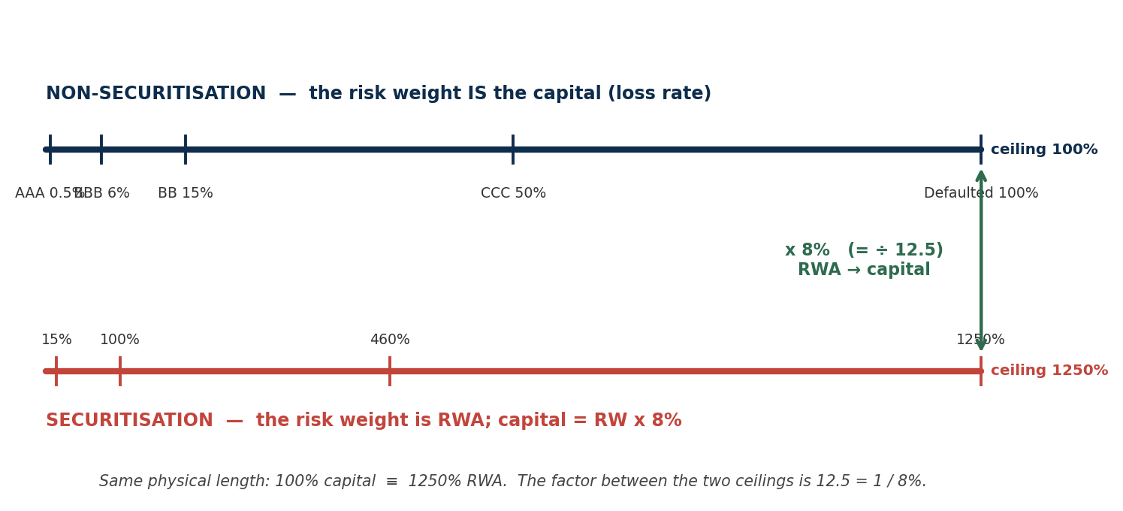
Exhibit 2. The two scales drawn to the same physical length. The non-securitisation scale ends at 100%; the securitisation scale ends at 1250%. 100% capital and 1250% RWA are the same point — the 8% factor (÷12.5) is the bridge between them.
THE TELL Wherever you see a 1250% in a risk-weight table, you are on the RWA scale — and an 8% multiplication is still pending. Non-securitisation tables never exceed 100%, because there is nothing past a total loss to express.
3. Non-securitisation — the risk weight is a loss rate
For non-securitisations, MAR22.24 sets the default risk weights directly by credit-quality category. These are loss rates: the fraction of the jump-to-default exposure you would expect to lose, expressed as capital. They are applied to net JTD with no further scaling — the DRC bucket formula (MAR22.25) reads RW x net JTD, and the output is already a capital charge.
Credit quality | AAA | AA | A | BBB | BB | B | CCC | Unrated | Defaulted
Default risk weight | 0.5% | 2% | 3% | 6% | 15% | 30% | 50% | 15% | 100%
Exhibit 3. MAR22.24 Table 2 — non-securitisation default risk weights. These are loss rates on the capital scale; the ceiling is 100% (a defaulted name = a full loss). No 8% is applied.
Read the table as loss given default: a defaulted name (100%) is charged its full net JTD; an AAA name (0.5%) is charged half a percent of it. Because the weights are already capital, multiplying by 8% here would be a mistake in the other direction — it would charge a defaulted name only 8% of its loss, a 12.5x under-statement of a position that is, by definition, gone.
4. Securitisation — the risk weight is an RWA weight
For securitisations, MAR22.34 does not publish its own loss rates. It imports the banking-book securitisation risk weights from CRE40-44 (SEC-ERBA, SEC-IRBA, SEC-SA, SEC-IAA), with one modification — the maturity parameter is set to one year. Those are RWA risk weights, and the framework says so explicitly. CRE44.24(2) (SEC-IRBA) and CRE41.10(2) (SEC-SA) define the risk weight as:
CRE44.24(2) / CRE41.10(2) "...the risk weight of the exposure, expressed as a percentage, would equal K x 12.5." Here K is the securitisation capital requirement (a fraction). The risk weight is K scaled up by 12.5 — i.e. it sits on the RWA scale, 12.5x above the capital it represents.
So to recover the capital you must undo the 12.5 — multiply by 8% (= 1/12.5): capital = RW x 8% x net JTD = (K x 12.5) x 8% x net JTD = K x net JTD. The 8% is not a fudge; it is the exact inverse of the CRE definition. The SEC-ERBA ratings table makes the RWA scale visible — it runs to 1250%, far past any loss rate:
Rating | Senior 1y | Senior 5y | Non-sr 1y | Non-sr 5y | Rating | Senior 1y | Senior 5y | Non-sr 1y | Non-sr 5y
AAA | 15% | 20% | 15% | 70% | BB+ | 140% | 160% | 470% | 580%
AA | 25% | 40% | 30% | 120% | BB | 160% | 180% | 620% | 760%
A | 50% | 65% | 80% | 180% | B | 310% | 340% | 1050% | 1050%
BBB | 90% | 105% | 220% | 310% | CCC | 460% | 505% | 1250% | 1250%
BBB- | 120% | 140% | 330% | 420% | Below CCC- | 1250% | 1250% | 1250% | 1250%
Exhibit 4. SEC-ERBA long-term risk weights (CRE42.4, Table 2 — selected rows). These are RWA risk weights, peaking at 1250%. DRC uses the 1-year column (MAR22.34 sets the maturity parameter to 1). Capital still needs x 8%.
5. The 8% bridge and the 1250% ceiling
The 8% is the Basel minimum capital ratio (RBC20): capital = 8% x RWA, equivalently RWA = capital x 12.5. Every banking-book risk weight obeys it. That single relationship explains the entire securitisation scale:
- 1250% is the deduction. 1250% x 8% = 100% of the exposure. The number 1250% exists precisely because it is the risk weight that, after the 8%, deducts the position in full. It is not '12.5 losses' — that is impossible — it is one full loss expressed on the RWA scale.
- 100% (sec) is a normal weight. 100% x 8% = 8% of the exposure — the weight of an ordinary performing claim. The same '100%' that means *total loss* in the non-securitisation table means *8% capital* in the securitisation framework.
- The DD-failure residual. A due-diligence failure forces 1250% (CRE40.41). With the 8%, that is a full deduction (100% of net JTD) — severe but bounded by the exposure. Without the 8%, it would charge 12.5x the exposure — a number with no economic meaning.
ONE LINE TO REMEMBER 1250% x 8% = 100%. The securitisation risk weight is RWA; the 8% turns it into capital; and the deepest charge the framework can levy is a full deduction — never a multiple of the position.
6. The 12.5x error, worked from portfolio
Four securitisation positions from the portfolio portfolio, spanning the full risk-weight range, show the trap concretely. 'Correct' applies the 8%; 'naive' forgets it. The overstatement is identical — 12.5x — on every one, because the 8% multiplies every position equally.
Position | Approach | Risk weight | net JTD (=MV) | Correct  RW x 8% x JTD | Naive  RW x JTD | Overstatement
RMBS senior (ID 37) | SEC-IRBA | 15% | $3.86m | $46,296 | $578,701 | 12.5x
AUTO senior (ID 50) | SEC-ERBA | 10% | $53.12m | $424,965 | $5,312,062 | 12.5x
NPL senior (ID 75) | SEC-IRBA | 100% | $26.85m | $2,147,738 | $26,846,720 | 12.5x
DD-fail CMBS (ID 71) | 1250% | 1250% | $0.90m | $896,980 | $11,212,255 | 12.5x
Exhibit 5. The 8% trap on four portfolio positions. The naive column omits the 8%; the overstatement is exactly 12.5x regardless of the risk weight, approach or seniority.
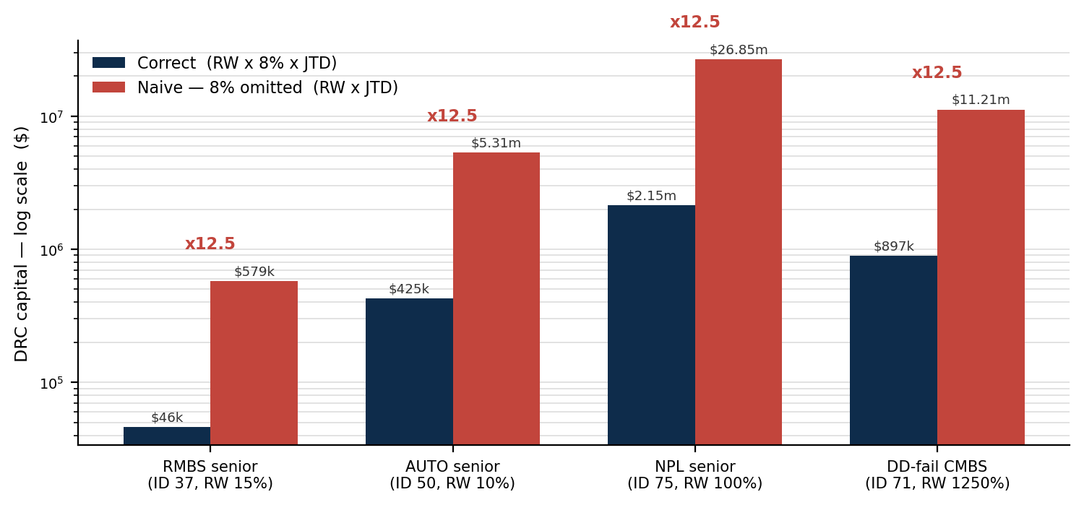
Exhibit 6. Correct versus naive capital (log scale) for the four positions. The crimson bar is 12.5x the navy bar in every pair — the constant signature of a missing 8%.
Note the two cases that most often prompt the question. The NPL senior (ID 75) carries a 100% risk weight: with the 8% it is charged $2.15m (8% of its $26.85m JTD); without it, the full $26.85m — treating a performing senior tranche as a total write-off. The DD-failure (ID 71) carries 1250%: with the 8% that is a full deduction equal to the exposure; without it, $11.2m on a $0.90m position — capital more than ten times the asset.
7. The '100%' trap — one number, two scales
The clearest way to be caught is the number 100%, because it is legal in both tables and means opposite things. In non-securitisation it is the Defaulted loss rate — a full loss. In securitisation it is an ordinary banking-book risk weight — 8% of the exposure. Same digits, a 12.5x difference in capital.
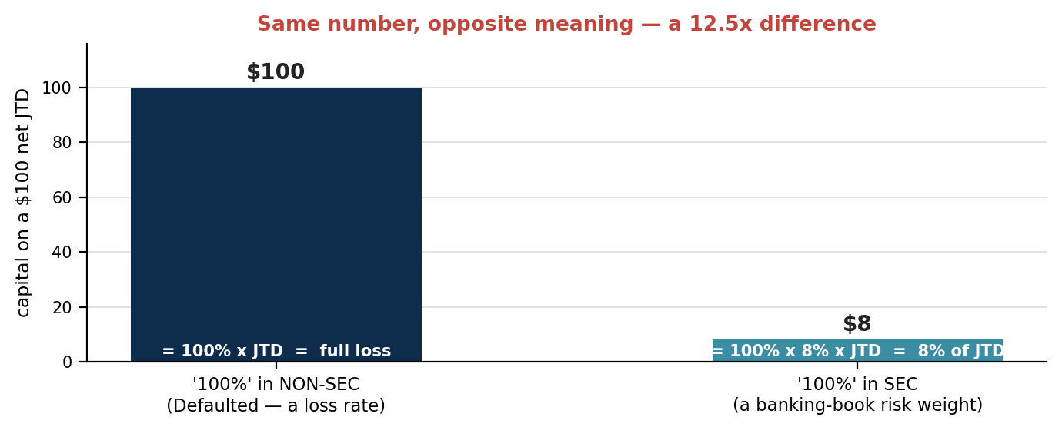
Exhibit 7. A $100 net JTD at '100%'. On the non-securitisation loss-rate scale that is $100 of capital (a full loss); on the securitisation RWA scale it is $8 (after the 8%). The label is identical; the capital differs by 12.5x.
PRACTITIONER'S RULE Before applying any risk weight, ask which scale am I on? If the table can reach 1250% (any securitisation approach — ERBA, IRBA, SA, IAA, or the 1250% residual), it is RWA — multiply by 8%. If the table stops at 100% (non-securitisation, MAR22.24), it is already capital — do not.
8. Why it matters & how the engine gets it right
This is not a rounding issue. A forgotten 8% on the securitisation branch multiplies its entire default-risk charge by 12.5 — turning the portfolio figure of $27.4m into $342.4m, a number larger than the securitisation book itself. The reverse error — applying 8% on the non-securitisation branch — would under-capitalise a defaulted name 12.5-fold, charging 8% where a full loss is due. Both are catastrophic, and both come from treating 'risk weight' as one thing.
The engine encodes the distinction structurally:
- Securitisation branch — the 8% factor (`rw_factor_to_capital = 0.08`) is applied once, where the risk weight meets net JTD in the bucket DRC step: capital = RW x 8% x net JTD. The residual and 1250%-table values therefore deduct in full, never beyond.
- Non-securitisation branch — the MAR22.24 loss rates are applied directly to net JTD, with no 8%. A defaulted name is charged its full JTD.
- Guardrail. A fingerprint check is available: if a securitisation position's capital exceeds its own fair value (other than at the 1250% deduction boundary, where they are equal), the 8% has been dropped. The MAR22.34(3) fair-value cap makes that boundary explicit.
BOTTOM LINE A securitisation risk weight is RWA (peak 1250%, = K x 12.5); a non-securitisation risk weight is a loss rate (peak 100%). The 8% Cooke factor converts the former to capital and must never touch the latter. Get the scale wrong and the capital is wrong by exactly 12.5x — in one direction a charge bigger than the book, in the other a defaulted name held at eight cents on the dollar.

Appendix A — Capital reconciliation (four positions)
Full arithmetic for the four worked positions, so every figure in Section 6 is auditable. For securitisations, capital = risk weight x 8% x |net JTD|, with net JTD = signed market value (MAR22.27) and the maturity parameter set to 1 (MAR22.34(1)). The 'naive' column drops the x 8%.
Step | ID 37 RMBS sr | ID 50 AUTO sr | ID 75 NPL sr | ID 71 DD-fail
Approach | SEC-IRBA | SEC-ERBA | SEC-IRBA | 1250% residual
Risk weight (RWA scale) | 15% | 10% | 100% | 1250%
x 8% -> capital ratio | 1.2% | 0.8% | 8.0% | 100.0%
|net JTD| (= |MV|) | $3,858,005 | $53,120,620 | $26,846,720 | $896,980
Correct capital | $46,296 | $424,965 | $2,147,738 | $896,980
Naive capital (no 8%) | $578,701 | $5,312,062 | $26,846,720 | $11,212,255
Overstatement | 12.5x | 12.5x | 12.5x | 12.5x
Exhibit 8. Position-level reconciliation. Row 3 (RW x 8%) is the capital ratio actually held; note it never exceeds 100%, the full-deduction boundary reached only by the 1250% residual.
The third row is the intuition in one line: after the 8%, a 1250% risk weight is a 100% capital ratio (full deduction), a 100% risk weight is 8% capital, and a 10-15% senior weight is roughly 1% capital. None can exceed 100%. Drop the 8% and every one of these ratios is multiplied by 12.5, breaching the 100% economic ceiling for all but the lowest weights.

References
Sources are consolidated here so the body reads as a continuous argument. The Basel consolidated framework texts (MAR and CRE chapters) and the risk-based-capital standards are the authoritative sources; the internal workbook and engine implement them and are cited for traceability of the figures, not as independent authority.
Primary standards — Basel consolidated framework
Reference | Title / provision | What it governs in this note
MAR22.24 | Default risk weights for non-securitisations (Table 2). | The non-securitisation loss-rate scale (0.5%-100%) applied directly, no 8% — Sections 1, 3, 7.
MAR22.25 | Bucket-level DRC formula (risk-weighted net JTD with HBR). | How the risk weight meets net JTD; the point at which the 8% enters on the securitisation branch — Sections 3, 4, 6.
MAR22.34(1), (3) | DRC securitisation (non-CTP): import of CRE40-44 risk weights with the 1-year maturity override; the fair-value cap. | Why securitisation DRC uses banking-book RWA weights; the deduction boundary — Sections 4, 5, 8.
CRE44.24(2) / CRE41.10(2) | SEC-IRBA / SEC-SA risk weight = K x 12.5. | The explicit definition that makes the securitisation risk weight an RWA weight requiring x 8% — Sections 4, 5.
CRE42.4 (Table 2) | SEC-ERBA long-term risk-weight table. | The ratings-based RWA risk weights (peak 1250%) shown in Section 4.
CRE40.41 | 1250% residual risk weight (due-diligence / no-approach). | The deduction-equivalent weight; the DD-failure example (ID 71) — Sections 5, 6.
RBC20 | Calculation of minimum risk-based capital requirements (the 8% ratio). | The source of the 8% factor and the 12.5 reciprocal — Sections 1, 5, 8.
Internal sources
Reference | Source | What it provides
FRTB_Sec_Config.xlsx | Securitisation configuration workbook (SEC_Constants, SEC-ERBA tables, Deal_Master). | rw_factor_to_capital = 0.08 (the 8% factor); the SEC-ERBA risk-weight table; the deal data behind IDs 37/50/71/75.
drc_securitisation engine | FRTB DRC securitisation pipeline (sec_loader, sec_erba/irba/sa, sec_engine step_10_bucket_hbr). | The capital = RW x 8% x net JTD computation; the portfolio totals ($27.4m correct; $342.4m if the 8% is dropped).
reference portfolio | FRTB_Combined_Portfolio_v5.xlsx — Combined Holdings. | The four worked positions (IDs 37, 50, 71, 75) and their model-priced market values.

